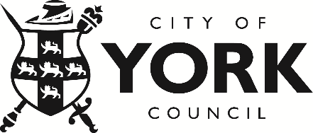

|  |
| --- |
| City of York Council  West Offices  Station Rise  York  YO1 6GA |
| Date: 17 July 2024 |

Dear Business colleague,

On behalf of City of York Council, we invite you to join us at the upcoming Armed Forces Covenant (AFC) Seminar, to be held on Monday 7 October 2024 in the Priory Street Centre (Main Hall) from 1:30pm to 5:00pm.

The main aim of the seminar is to provide an environment where organisations can learn more about the Armed Forces Covenant and the Employer Recognition Scheme at Bronze, Silver or Gold level, with a view to encouraging you to sign up, or perhaps take the next step in progressing from Bronze to Silver or Silver to Gold.

Attendees will get to listen to a number of case studies that focus on lived experiences. Subject to final confirmation this will include hearing from:

* a Reservist about their experience of working for an Armed Forces friendly employer and the mutual benefits that are available.
* a member of the regular Armed Forces that is transitioning/will transition to civilian life now or in the near future.
* a local employer that has first hand experience of the benefits linked to recruiting from the Armed Forces Community.

Kindly RSVP, using the form overleaf, by Friday 27th September to confirm your attendance. Should you require any further information or assistance, please do not hesitate to contact [afc@york.gov.uk](mailto:afc@york.gov.uk)

We eagerly anticipate your presence.

Yours faithfully,

The City of York Council Armed Forces Team

Please complete the following form per each attendee:

|  |  |
| --- | --- |
| Applicant Details | |
| Company, Organisation or Business Name |  |
| Applicant Name |  |
| Applicant Job Title |  |
| Applicant Email Address |  |
| Applicant Telephone Number |  |
| Interest in event | (please delete as appropriate)   * find out about the Armed Forces Covenant and the MOD Employer Recognition Scheme * sign the Covenant and achieve Employer Recognition Scheme Bronze level * progressing from Bronze to Silver level * progress from Silver to Gold level * maintain Gold level |
| Dietary requirements or allergies |  |

**Further Reading**

Armed Forces Covenant:

<https://www.armedforcescovenant.gov.uk/>

<https://www.york.gov.uk/ArmedForcesCovenant>

Employer Recognition Scheme:

<https://www.gov.uk/government/publications/defence-employer-recognition-scheme>

<https://www.rfca-yorkshire.org.uk/employers/recognition-scheme/>